Warning – cHUD – CGEA 1.3

Functional Description

The purpose of the cHUD Warning feature is to inform the driver when they are not properly opening the cHUD or when a blockage or fault exists in the cHUD. The cHUD Warning feature correlates the HudMsgTxt_D_Rq CAN signal, the configuration information, and the operational mode to display the appropriate warning display in the message center.

Interfaces

Interface Context Diagram (I/O Block Diagram)
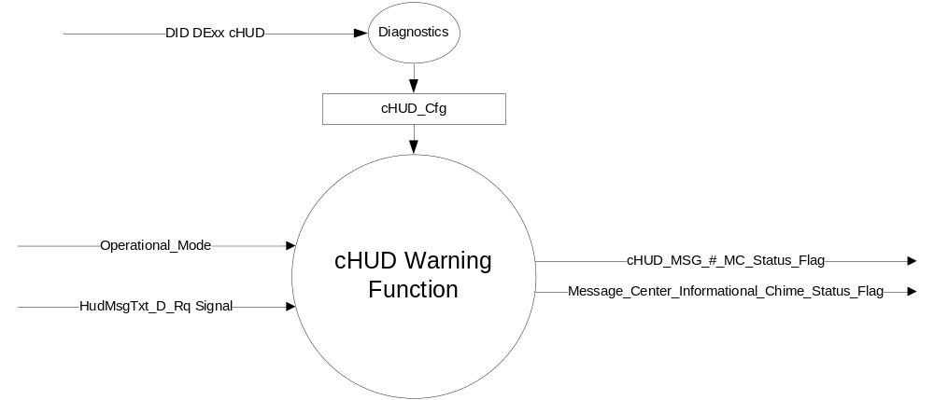

Figure 1 Warning – cHUD Warning Function Context Diagram

Inputs

      - INTERNAL:
            - Operational_Mode

- MUX message from the CAN bus

- HudMsgTxt_D_Rq Signal
Signal Name | Size (bits) | Detail | Units | Res. | Offset | State  Encoded | Min | Max
HudMsgTxt_D_Rq | 3 |  | SED | 1 | 0 |  | 0 (0x0) | 7 (0x7)
 |  | No Message |  |  |  | 0x0
 |  | Message 1 |  |  |  | 0x1
 |  | Message 2 |  |  |  | 0x2
 |  | Message 3 |  |  |  | 0x3
 |  | Message 4 |  |  |  | 0x4
 |  | Message 5 |  |  |  | 0x5
 |  | Message 6 |  |  |  | 0x6
 |  | Message 7 |  |  |  | 0x7

Outputs
- cHUD_MSG_#_MC_Status_Flag that is used to control the Warning displayed in the message center.
- Message_Center_Informational_Chime_Status_Flag that is used to control the Warning Chime.

Function/Performance

Operational Modes

Mode | Differentiating Vehicle Conditions
Sleep Mode | OFF
Limited Mode | OFF
Normal Mode | cHUD Warning OFF/ON
Crank Mode | cHUD Warning OFF/ON

Voltage Levels

Refer to the Cluster Features Table located in the Operational Modes and Voltage Range Strategies Section of this SPSS.

Human-Machine Interface

Visual

Indicator Graphics / Display Format
Message Center Text Warning Message as defined in section 1.3.5.1 of this document.

1.3.3.1.2 Indicator Color Coordinates

Reference section COLOR & ILLUMINATION REQUIREMENTS (GRAPHICS)

1.3.3.1.3 Indicator Characteristics

Refer to Message Center X Display_Y Button Interface Section, where X and Y are appropriate values in this document.

Audio

Message_Center_Informational_Chime_Status_Flag.

Switch Control Logic

None.

System Accuracy

The state of the message center flags shall change within 100 msec of a state change as indicated in the state matrix found in section 1.3.5.1 of this document

Operation: Performance and Functional

Subsystem Algorithm Flowchart / State Diagram

- cHUD_MSG_#_MC_Status_Flags
Operational  Mode | HudMsgTxt_D_Rq | cHUD_MSG_1_MC_Status_Flag | cHUD_MSG_2_MC_Status_Flag | cHUD_MSG_3_MC_Status_Flag | cHUD_MSG_4_MC_Status_Flag | cHUD_MSG_5_MC_Status_Flag | cHUD_MSG_6_MC_Status_Flag | cHUD_MSG_7_MC_Status_Flag
Normal or  Crank | 0x1 (Message 1) | Active | Inactive | Inactive | Inactive | Inactive | Inactive | Inactive
Normal or  Crank | 0x2 (Message 2) | Inactive | Active | Inactive | Inactive | Inactive | Inactive | Inactive
Normal or  Crank | 0x3 (Message 3) | Inactive | Inactive | Active | Inactive | Inactive | Inactive | Inactive
Normal or  Crank | 0x4 (Message 4) | Inactive | Inactive | Inactive | Active | Inactive | Inactive | Inactive
Normal or  Crank | 0x5 (Message 5) | Inactive | Inactive | Inactive | Inactive | Active | Inactive | Inactive
Normal or  Crank | 0x6 (Message 6) | Inactive | Inactive | Inactive | Inactive | Inactive | Active | Inactive
Normal or  Crank | 0x7 (Message 7) | Inactive | Inactive | Inactive | Inactive | Inactive | Inactive | Active
All other Cases |  | Inactive | Inactive | Inactive | Inactive | Inactive | Inactive | Inactive

- cHUD_MSG_#_MC_Status_Flags to MC Warning Message ID and Chime_Status_Flag
cHUD_MSG_1_MC_Status_Flag | cHUD_MSG_2_MC_Status_Flag | cHUD_MSG_3_MC_Status_Flag | MC Warning  Message ID | Message_Center_Informational_  Chime_Status_Flag
Active | Inactive | Inactive | W3551 | Inactive
Inactive | Active | Inactive | W3551 | Inactive
Inactive | Inactive | Active | W3552 | Active
Inactive | Inactive | Inactive | None | Inactive

Operation Description (supports algorithm flowchart /state diagram)

- Message Center Warning ID W3551 will be Active whenever cHUD_MSG_1_MC_Status_Flag or cHUD_MSG_2_MC_Status_Flag is True and the operational mode is Normal/Crank. This warning will be Active whenever there is a blockage or cHUD fault that prevents the cHUD from opening or closing.
- Message Center Warning ID W3552 and the Message_Center_Informational_Chime_Status_Flag will both be Active whenever cHUD_MSG_3_MC_Status_Flag is True and the operational mode is Normal/Crank. This warning will be Active whenever the cHUD detects the a mis-use such as the driver trying to open the cHUD by hand and not through the menu.

Function Safety Classification (EMC)

Class B

Memory Storage

Parameter Name | Description | Value at  Battery Connect | Value at  Module  Wake-up
cHUD_MSG_#_MC_Status_Flag | Used to control the state of the warning to the Message Center arbitrator | Inactive (0X0) | Inactive (0X0)
HudMsgTxt_D_Rq | CAN signal | 0x0 | 0x0
Message_Center_Informational_Chime_Status_Flag | Used to control the state of the warning chime to the Chime arbitrator | Inactive (0X0) | Inactive (0X0)
Operational_Mode | 4 state indicator for cluster operational mode | Limited | Limited or Normal or Crank

Prove Out

No.

Reconfigurable Telltale

No.

Message Center Msg

Refer to Text: Program Master Warning Message List.xls | Program Translation Table.xls warning W3551 and W3552.

Error Handling

Missing Message/Undefined Data Strategy

None

Invalid Message Strategy

None.

Diagnostics

Self Test

None

Engineering Test Mode

Reference section “Dealer / Engineering Test Mode (ETM)”

Part II Performance

Supported Diagnostic DIDs (Service $22 and $2F)

Supported Diagnostic Trouble Codes (DTCs)
DTC | Description | When Logged

DID DExx Configuration
Block  Num | Block Description | Byte(s) | Bits | State: Description | "0" | "1" | Default | Comments/Information
PACKETED BLOCKS
$xx | Option Content (B&A) | * | * | cHUD | Disabled | Enabled | Disabled | Disabled means the feature is not presented in the vehicle.
*Byte and bit location to be identified in Part II Specification for this cluster

Reference Specification

IS-0001 WARNINGS/INDICATORS/DISPLAYS PROVEOUT
IS-0052 OPERATING VOLTAGES - FUNCTIONAL/PERFORMANCE
IS-0069 FUNCTIONAL IMPORTANCE CLASS
IS-0324 WINDSHIELD & OTHER REFLECTIONS
IS-0327 WARNING INDICATOR EVALUATION
IS-0379 NORTH AMERICAN WARNINGS AND INDICATORS STRATEGY

IL-0017 TELLTALE AND INTERIOR ILLUMINATION – COLOR AND INTENSITY
IL-0019 GENERAL ILLUMINATION DIMMING
IL-0021 CRAFTSMANSHIP – DISPLAYS
IL-0022 GENERAL ILLUMINTATION COLOR
IL-0023 CLARITY/LEGIBILITY/READABILITY/VISUAL CONTRAST
IL -0043 OPERATIONAL ENVIRONMENT FUNCTIONALITY
IL -0045 COLOR
IL -0047 TELLTALE, INDICATOR AND DISPLAY LIGHT INTENSITY
IL -0048 ILLUMINATION ACCEPTABILITY

03-0661 PLACEMENT: CONTROL AND DISPLAY LOCATIONS
03-0662 PLACEMENT: LOGICAL GROUPING FUNCTION AND USAGE
03-0664 PLACEMENT: DOWN VISION TO COMPONENTS WITH HIGH VISUAL DEMAND
03-0665 PLACEMENT: EXPECTED LOCATIONS OF CONTROLS AND DISPLAYS VDS
03-0670 INTERIOR VISIBILITY
03-0671 INTERIOR VISIBILITY: REFLECTIONS FROM COMPONENTS & SURFACES
03-0672 INTERIOR VISIBILITY: REFLECTIONS IN DISPLAYS
03-0673 INTERIOR VISIBILITY: VISUAL OBSCURATIONS
03-0674 INTERIOR VISIBILITY: ILLUMINATION CONTROLS / DISPLAYS
03-0675 INTERIOR VISIBILITY: VEILING GLARE
03-0677 INTERIOR VISIBILITY: SUNLIGHT WASHOUT
03-0681 IDENTIFICATION: CHARACTER AND SYMBOL SIZE
03-0682 IDENTIFICATION: LEGIBILITY
03-0685 IDENTIFICATION: SYMBOLS, ABBREV FOR CONTROL
03-0721 LOGIC OF OPERATION: OPERATIONAL STEREOTYPES
03-0722 LOGIC OF OPERATION: INTERPRETATION
03-0723 LOGIC OF OPERATION: USE OF SYSTEMS WITH VISUAL DISPLAYS

Revision History

SPSS Module Revision History

Revision Level | Name | Change Description | Date
1.0 | J. Gregoire | Initial Release. Felix Mueller (fmuell30) is the feature owner. | 3/14/2016
1.1 | J. Gregoire | Correct typo in waring number. W3351 should be W3551 and W3352 should be W3552.  Page 3 Table 1.2 – Update W3351 to W3551.  Page 3 Section 1.3.5.2 – Update W3351 to W3551 and W3352 to W3552. | 2/21/2018

